7 Categorical data: Advanced methods

This chapter covers
- Combining continuous and categorical data in an analysis
- Converting continuous data to categorical when it is appropriate to do so
- Analyzing categorical data with advanced methods, such as statistical tests
Please ignore grammar errors and typos. What you see is a raw manuscript; it has not been copyedited.
In this chapter, we will continue exploring the value of categorical data. In the previous chapter, we explored survey data, which was mostly categorical, and answered some of our stakeholders’ questions with methods appropriate for categorical data. This chapter dives into more advanced methods: performing statistical tests with categorical data and combining continuous and categorical data. We will first recap the project brief from the previous chapter and summarize the work done so far before continuing with the analysis.

7.1 Project 5 revisited: Analyzing survey data to determine developer attitudes to AI tools
To recap, we are analyzing the Stack Overflow Developer Survey to determine how coders are using AI tools. Our stakeholders are interested in testing two of their hypotheses:
- New and experienced coders are using these tools differently from each other
- People’s opinions on the usefulness and trustworthiness of current AI tools depend on their experience, job role, and what specifically they use the tools for
We have answered the second part by exploring, reshaping, and summarizing categorical columns in our survey data. The following section describes the available data.

7.1.1 Data dictionary
The data dictionary for this dataset comes in two parts, both included in the supplementary materials:
- There is a question-by-question breakdown, survey_results_schema.csv, documenting which question a column contains answers for. Some questions’ answers are spread across multiple columns.
- There is also a PDF copy of the survey itself. With this, you can directly observe the data-generating process, which is usually rare.
Let’s revisit our desired outcomes, so we know what result to aim towards.

7.1.2 Desired outcomes
Our stakeholders have specific hypotheses, and our analysis should focus on them. We have already done some general exploration of the data to identify elements like missing values. Our Minimum Viable Answer should be evidence to support or falsify the main hypotheses. Therefore:
- Our conclusions should include whether or not there is a difference in the use of AI across different levels of experience
- We should communicate the factors that affect a person’s opinion of, and trust in, AI tools, as supported by the survey data
Before continuing our analysis, let’s revisit the work we have done so far in the previous chapter.

7.1.3 Part 1 analysis summary
In the previous chapter, we:
- Explored the survey questions to find the ones relevant to our analysis
- We investigated missing data
- We analyzed both AI users’ and non-users’ trust and views on favorability of AI tools
- We explored the different purposes for which AI users use these tools and how different usage purposes affect users’ trust
- We investigated the different job roles among respondents and how trust and favorability varies across these roles
Figure 7.1 shows the work done so far.

Figure 7.1 steps in our analysis so far in the previous chapter
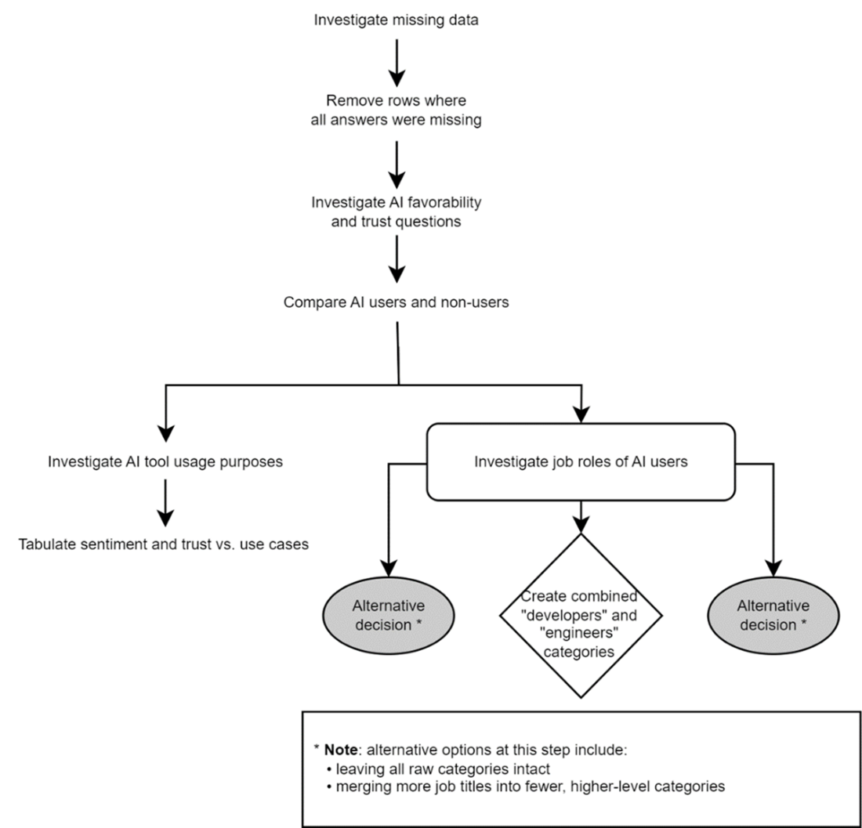
Up
In this chapter, we will answer questions about the respondents’ levels of experience. We are interested in whether having more coding experience changes opinions on AI tools and whether experienced users have different use cases than beginner coders.
Any comments on section 7.1 Project 5 revisited: Analyzing survey data to determine developer attitudes
to AI tools?

Up

7.2 Using advanced methods to answer further questions about categorical data
It is reasonable to believe that more experienced coders need different kinds of help from AI tools than more junior developers. Let’s see the values in the YearsCodePro column, which asks how many years the respondent has been coding. The output of the following code, which starts with reading in data exported at the end of the previous chapter, is shown in figure 7.2.
1
2
3
4
survey = pd.read_parquet("./data/survey.parquet.gz")
survey_ai_users = pd.read_parquet("./data/survey_ai_users.parquet.gz")

survey_ai_users["YearsCodePro"].unique()
copy

Figure 7.2 different values for “years of experience”
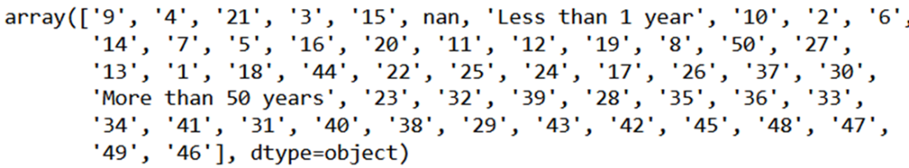
Up

This column should be numeric but is actually stored as text because of those two values: “less than 1 year” and “more than 50 years”. Since the rest of the values are not binned, we should make this column numeric. We can replace those two text values with 0 and 50, respectively, without compromising the data too much.
1
2
3
4
5
6
7
8
survey_ai_users["YearsCodePro"] = (
survey_ai_users["YearsCodePro"]
.replace({
'Less than 1 year': 0,
'More than 50 years': 50
})
.astype(float) # to account for NULLs
)
copy

Note
In later versions of pandas, 2.0 and beyond, there are actually nullable integer types. That is, numbers that represent integers but can also be missing. For the example solutions, I am using a version before 2.0, which only allows the float type, that is, decimal numbers, to contain missing values.
Now that we have a numeric “years of experience” column, let’s observe its distribution. The resulting histogram is shown in figure 7.3.
survey_ai_users["YearsCodePro"].hist(bins=20)
copy

Figure 7.3 distribution of AI users’ coding experience
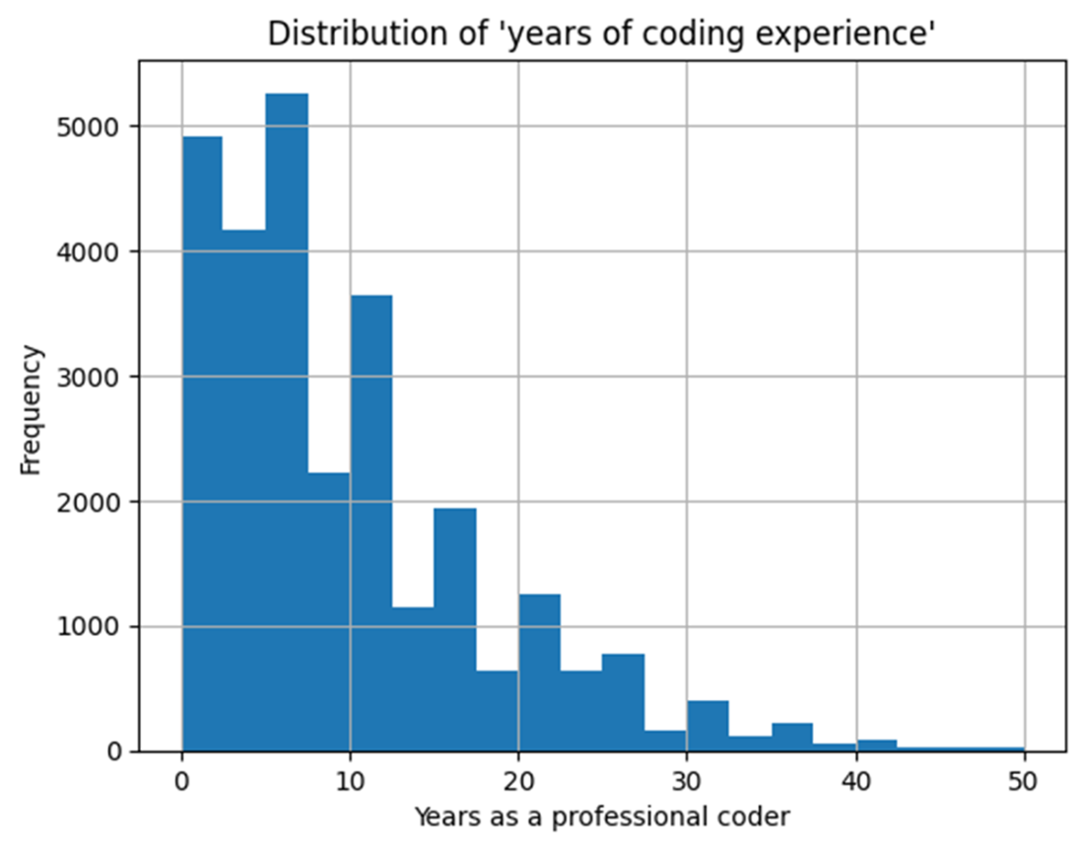
Up

Most participants have less than ten years of experience, with a long tail out towards 50. Now, if we were to test the relationship between this continuous value and another, we could simply calculate the correlation. However, we are trying to compare this against categorical data, such as how favorable someone views AI, so correlation in the traditional sense does not apply. One idea is to separate out this histogram of experience or similar visualizations of distribution, such as box plots, by the different answers to the favorability question. Let us look at an example using something the Python library seaborn calls “boxenplots”, which are similar to box-and-whisker plots but with more information. The following code results in the plot in figure 7.4.
1
2
3
4
5
6
7
8
9
10
11
12
13
14
15
16
17
fig, axis = plt.subplots()

sns.boxenplot(
data=survey_ai_users,
x="YearsCodePro", y="AISent",
color="gray",
ax=axis
)

axis.set(
title="Distribution of years of experience across
➥ answers to the favorability question",
xlabel="Years of coding experience",
ylabel="How favorably do you view AI tools?"
)

plt.show()
copy

Figure 7.4 distribution of experience across different answers to the AI favorability question
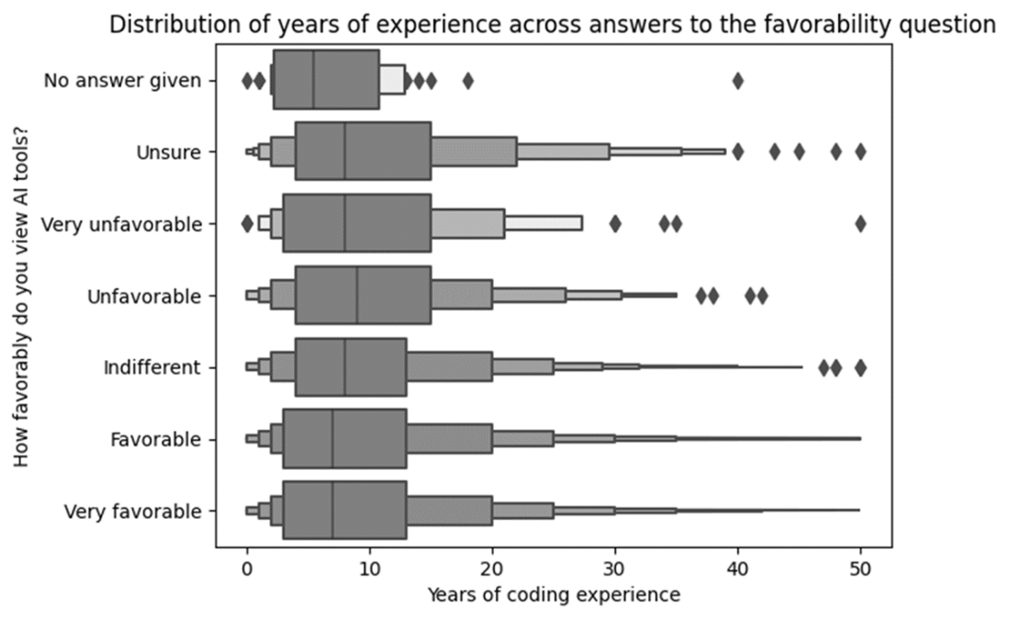
Up

This plot tells us that the highest median years of experience is in the “unfavorable” group. That is, the ones who view AI tools unfavorably are, on average, the more experienced coders. However, this median value is not a lot higher than other groups, and each group has a lot of variance. Let’s now look at how much different experience levels trust the output of AI tools. The following code produces the boxenplot in figure 7.5.
1
2
3
4
5
6
7
8
9
10
11
12
13
14
15
16
17
fig, axis = plt.subplots()

sns.boxenplot(
data=survey_ai_users,
x="YearsCodePro", y="AIBen",
color="gray",
ax=axis
)

axis.set(
title="Distribution of years of experience across
➥ answers to the trust question",
xlabel="Years of coding experience",
ylabel="How much do you trust the output of AI tools?"
)

plt.show()
copy

Figure 7.5 distribution of years of experience across answers to the trust question
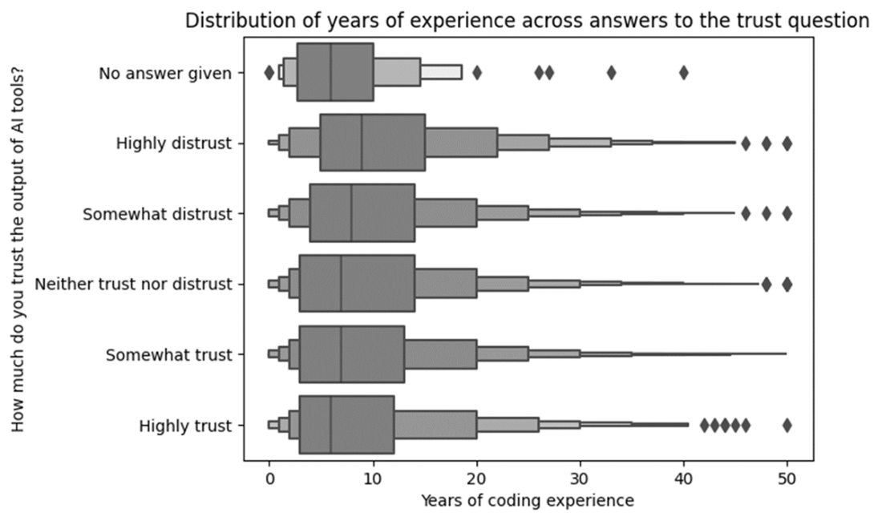
Up

Again, those who gave the more negative answers tend to have more experience on average. The difference is possibly higher than with favorability and also suggests that more experienced coders are less likely to trust the output of such tools. What we really want to know is the opposite question: rather than “what is the distribution of experience across different answers?” we want to know, “what is the distribution of different answers across experience levels?”
For this, we need another crosstab-to-heatmap process, this time comparing years of experience and answers to the favorability and trust questions. However, we can only do this if “years of experience” is represented as a categorical value.

Binning continuous values to discrete categories
We start by putting the continuous measure into categorical bins. Let’s create six logical bins in total, but remember that your choice of bins will affect the result. The following code bins our data and verifies the minimum and maximum years of experience within each bin, using the output shown in figure 7.6.
1
2
3
4
5
6
7
8
9
exp_bins = pd.cut(survey_ai_users["YearsCodePro"],
bins=[-1, 0, 2, 5, 10, 20, 50],
labels=["0", "1-2 years", "3-5 years",
"6-10 years", "11-20 years",
"over 20 years"]
)

# verify the groups
survey_ai_users.groupby(exp_bins)["YearsCodePro"].agg(["min", "max"])
copy

Figure 7.6 our years of experience bins with the minimum and maximum experience within each group also shown
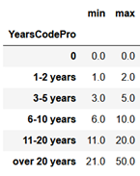
Up

Now that our experience column is categorical, we can look at its distribution. This is achieved by the following code, and the output is shown in figure 7.7.
1
2
3
4
5
6
7
8
9
10
11
12
13
14
15
16
17
fig, axis = plt.subplots()

(
exp_bins
.value_counts()
.sort_index()
.plot
.bar(ax=axis)
)

axis.set(
title="Distribution of years of experience (binned)",
xlabel="Years of experience",
ylabel="Frequency"
)

plt.show()
copy

Figure 7.7 distribution of the newly-binned years of experience data
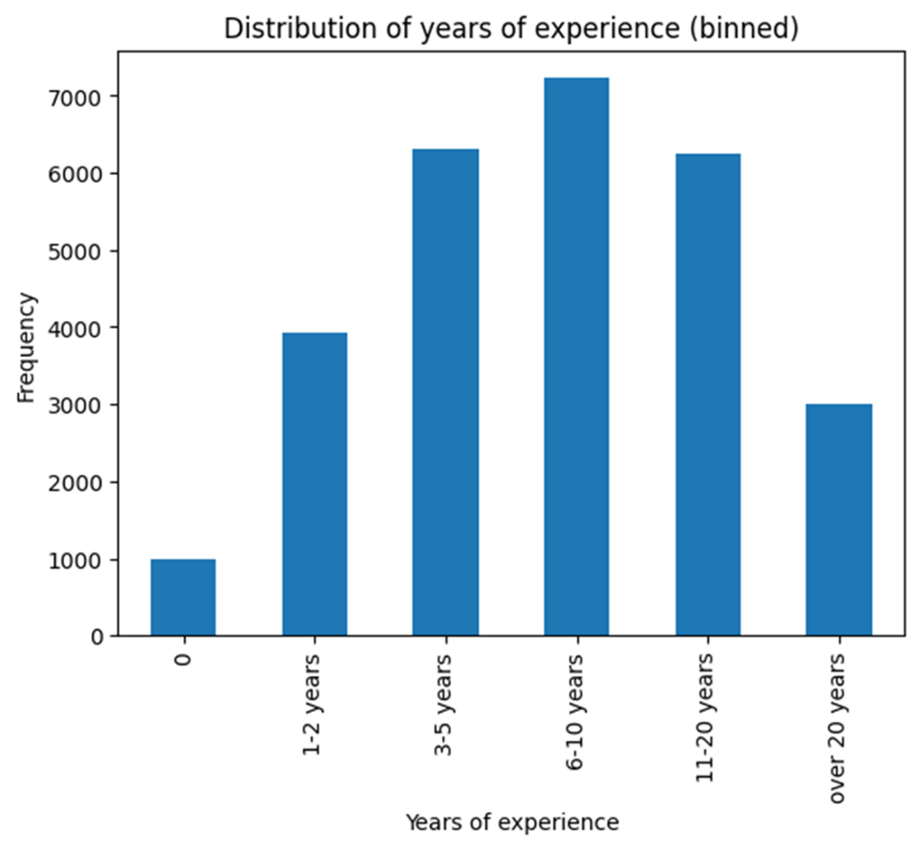
Up

As shown by figure 7.7, most participants have less than ten years of coding experience, with 6-10 years being the most common. Unlike the different AI tool use cases, this experience value is in a single column and is not spread across multiple indicators. That makes our crosstab creation much simpler because we are simply cross-tabulating two categorical columns. The following code achieves this and produces the output in figure 7.8.
1
2
3
4
5
6
7
exp_vs_sent = pd.crosstab(
index=exp_bins,
columns=survey_ai_users["AISent"],
normalize="index"
)

exp_vs_sent
copy

Figure 7.8 crosstab of experience vs. answers to the favorability question
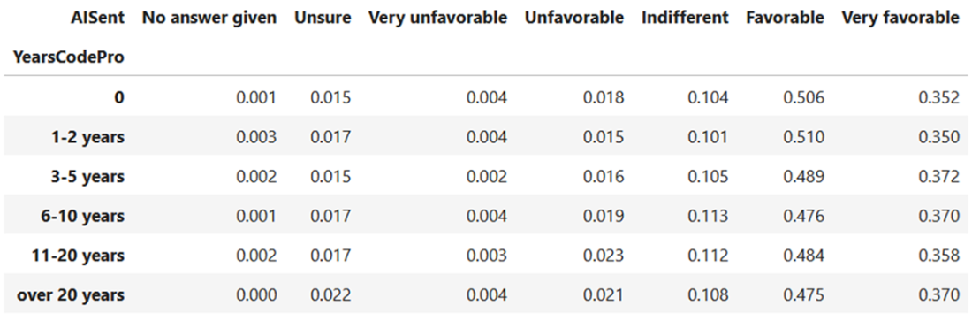
Up

As with previous examples, this is better explored as a heatmap, which is produced by the following code and shown in figure 7.9.
1
2
3
4
5
6
7
8
9
10
11
12
13
fig, axis = create_heatmap(
exp_vs_sent.round(2)
)

fig.suptitle("How favorably do people with different
➥ amounts of coding experience view AI?")

axis.set(
xlabel=None,
ylabel="Coding experience"
)

plt.show()
copy

Figure 7.9 heatmap of favorability vs. experience
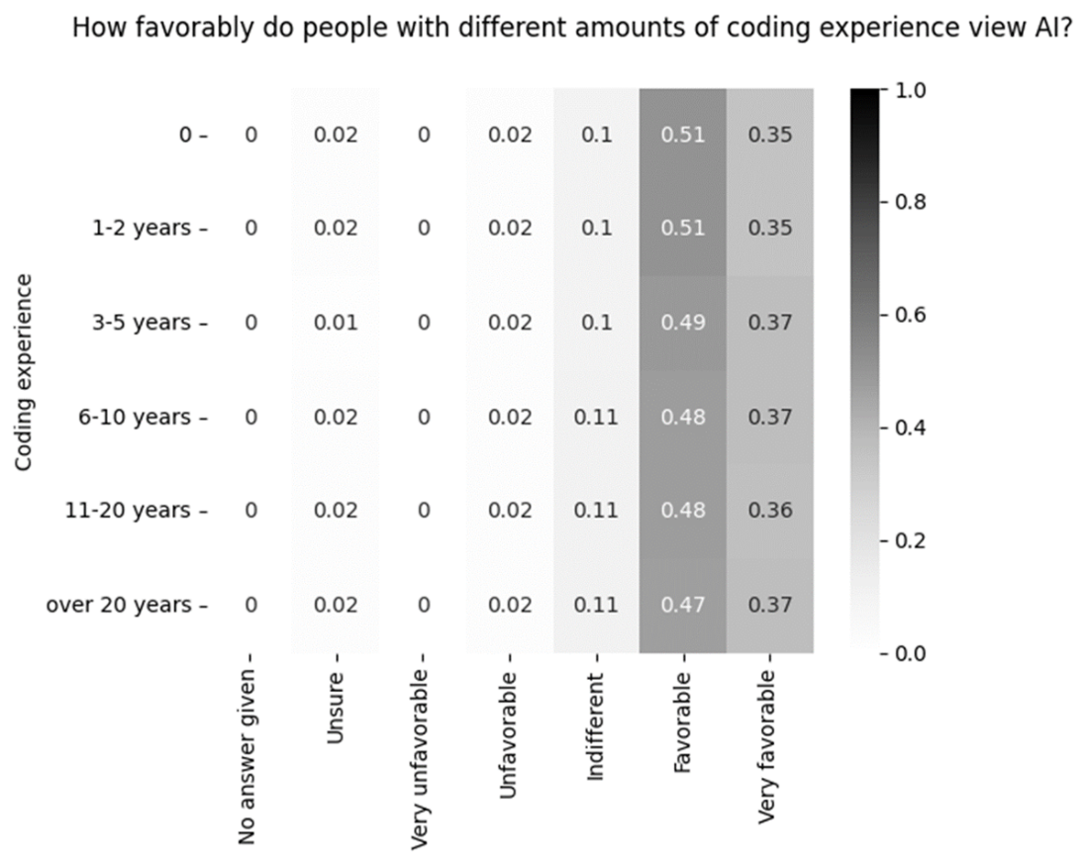
Neutral – some missing values
While figure 7.4 showed that those who rated AI tools unfavorably were slightly more experienced cohorts, when flipping the question, it appears that the answers of most cohorts are distributed equally. What about trust in AI tools? The following code creates both the crosstab and heatmap, and the latter is shown in figure 7.10.
1
2
3
4
5
6
7
8
9
10
11
12
13
fig, axis = create_heatmap(
exp_vs_trust.round(2)
)

fig.suptitle("How much do people with different
➥ amounts of coding experience trust the output of an AI?")

axis.set(
xlabel=None,
ylabel="Coding experience"
)

plt.show()
copy

Figure 7.10 coding experience vs. trust shown as a heatmap
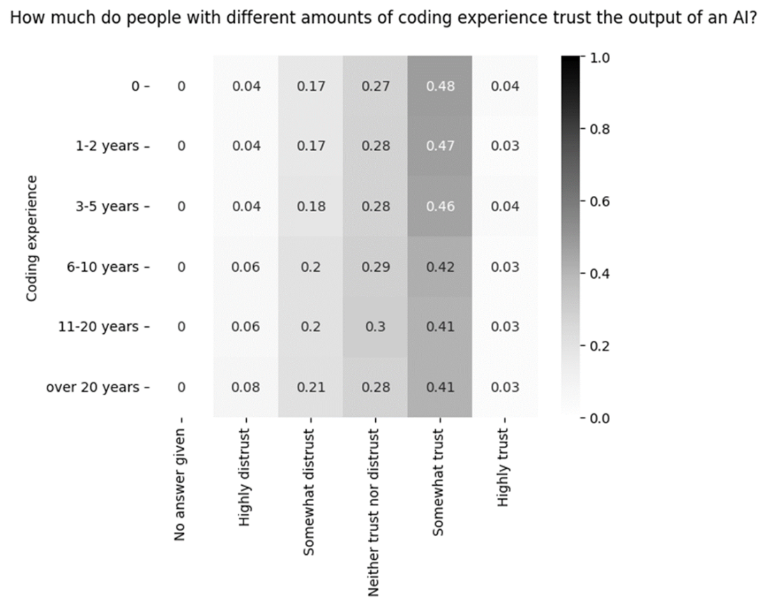

Down - Where was exp_vs_trust defined?
This heatmap paints a similar picture to that of figure 7.5. It seems that the more experience someone has, on average, the less trust they have in the outputs of AI tools. This is a great place to consider the use of a statistical test. We want to know whether this finding is supported statistically. Specifically, our hypothesis is that the continuous measure of “years of experience” affects someone’s answer to the question about trust in AI tools’ output.

Using statistical tests for categorical data
Most statistical tests covered in data education are designed for continuous measures. However, there are statistical tests specifically for categorical data or a mix of data types. This is a perfect example of something you might be aware of but not have the required specific knowledge until you need it for a project. It is, therefore, something with which you can turn to an AI tool.
Let’s see what ChatGPT says when asked the following:
- What methods can I use to measure the association between a continuous and an ordinal variable?
It gives multiple approaches, including visualizations that we have already performed. It summarizes its recommendations with “If you're interested in the overall strength and direction of the relationship, Spearman's rank correlation or Kendall's Tau can be useful.” These sound like good places to start.
Both of these methods are rank-based, meaning they do not use the ordinal values directly but their rank among all answers. This might again be something you haven’t done with your specific tool before, and an AI tool could give you a relevant code snippet. Figure 7.11 shows ChatGPT’s answer when prompted to give sample code to calculate Spearman’s rank correlation with Python.

Figure 7.11 ChatGPT’s code snippet to calculate Spearman’s rank correlation
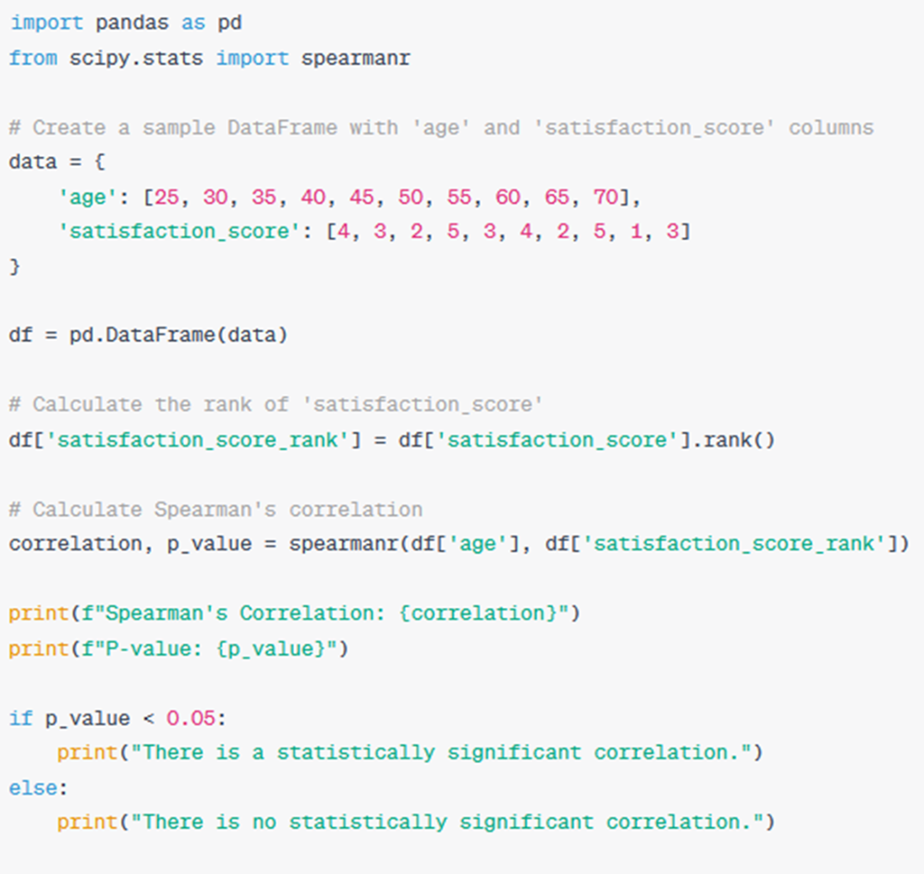
Up
Obviously, this code snippet isn’t directly useable, but it requires just a few modifications. Let’s apply ChatGPT’s code to our own and calculate Spearman’s rank correlation, as well as Kendall’s Tau value, which can be done in a similar manner. Two minor points to make here are that we have to drop any missing data for this analysis and ignore cases where no answer was given to the trust question since that value doesn’t fit into the ordinal nature of the answers. First, we will create the ranking and then calculate the two statistical metrics. The output, the final printout, is shown in figure 7.12.
1
2
3
4
5
6
7
8
9
10
11
12
13
14
15
16
17
18
19
20
21
22
23
24
25
26
27
28
29
trust_exp_data = (
survey_ai_users
.dropna(subset=["YearsCodePro", "AIBen"], how="any")
.loc[survey_ai_users["AIBen"] != "No answer given", :]
)

trust_rank = (
pd.Series(
trust_exp_data["AIBen"]
.factorize(sort=True)[0]
)
.rank()
)

from scipy.stats import spearmanr, kendalltau

correlation, p_value = spearmanr(
trust_exp_data["YearsCodePro"],
trust_rank
)

print("Spearman's\n", correlation, p_value)

correlation, p_value = kendalltau(
trust_exp_data["YearsCodePro"],
trust_rank
)

print("Kendall's tau\n", correlation, p_value)
copy

Figure 7.12 output of our statistical tests
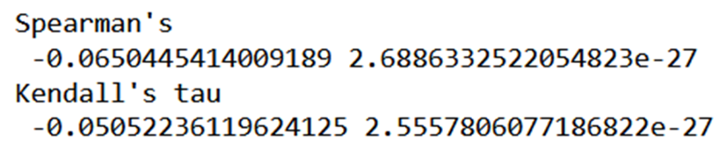
Up

In both of these tests, a value close to 0 means the association between variables is weak. The second value in both printouts is the p-value, a proxy for the significance of the result. A value close to zero means it is extremely unlikely we would see these results in a world where our base, or “null,” hypothesis is true. That is to say, in a world where we assume there is no association between experience and trust score, how likely are we to calculate the association value at which we arrived? The lower this likelihood, the more confident we can be that our correlation value is robust. A low p-value means we are inclined to reject the null hypothesis, meaning we accept that there is a statistically significant association.
In summary, our statistical tests tell us there is evidence of a significant but weak link between experience and trust scores. Experienced users may distrust AI slightly more, but the association is weak, and there are other factors at play. We are still free to explore this association further, but if a stakeholder insists on asking about statistical significance, we have an answer ready.
Let’s review the process so far, including the parallel strands that comprised our analysis, as shown in figure 7.13.

Figure 7.13 the analysis so far, including multiple parallel strands
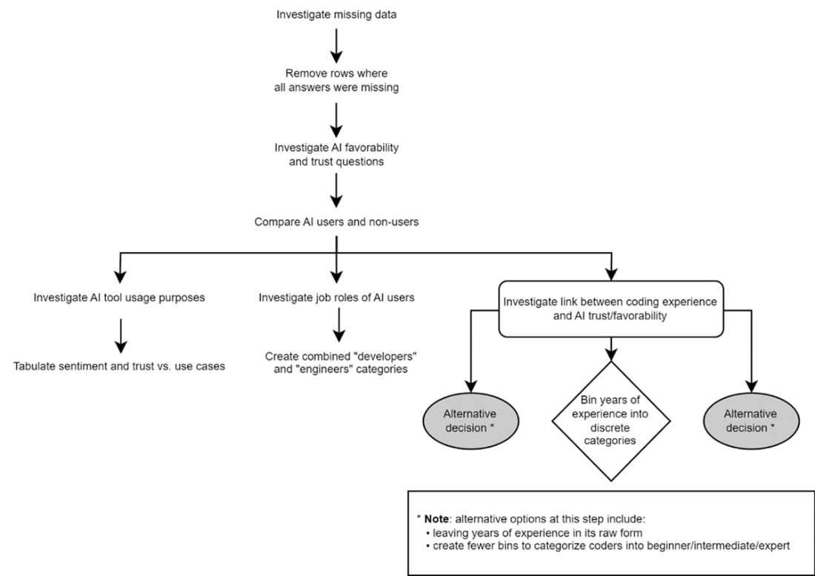
Up

The final point of inquiry before summarizing our results is to look at what developers are not interested in using AI tools for.

Answering a new question from start to finish
Looking at what developers are not interested in requires all the skills we have gained so far throughout this project. The survey specifically allows participants to tick a box for whether each use case is something they’re not interested in so we can look at this data directly. This will be useful in determining if a market opportunity actually exists. Since the answers to this question are recorded the same way as those for which participants are currently using AI tools for, we can go through the same process:
- Create indicator variables for each AI use case (this time from the AIToolNot interested in Using column)
- Add the indicators to the survey data for AI users only
- Create a long-form dataset cross-referencing job role with the use cases people aren’t interested in
- Use this long-form dataset to create a crosstab
- Visualize this crosstab as a heatmap
Let’s start with the indicator variables, after which we can look at which use cases people are least interested in, as shown in the bar chart in figure 7.14.
1
2
3
4
5
6
7
8
9
10
11
12
13
14
15
16
17
18
19
20
21
ai_not_interested_indicators = (
survey.loc[survey["AISelect"] == "Yes", "AIToolNot interested in Using"]
.str.get_dummies(sep=";")
)

fig, axis = plt.subplots()

(
ai_not_interested_indicators
.mean()
.sort_values()
.plot
.barh(ax=axis)
)

axis.set(
title="What do AI users NOT want to use AI for?",
xlabel="% of participants who ticked that option"
)

plt.show()
copy

Figure 7.14 which use cases people are least interested in using AI for
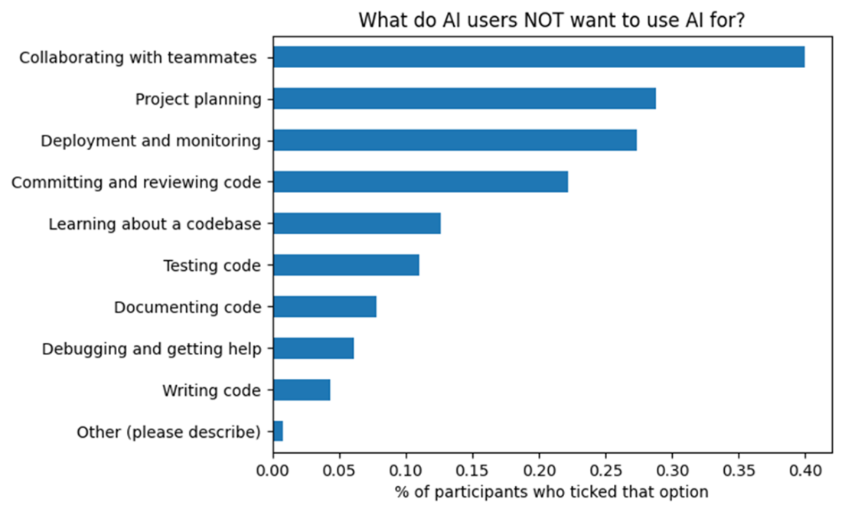
Up

Previous findings, such as the heatmap in figure 6.45 in the previous chapter, showed that very few people are using AI for collaboration, and figure 7.14 reinforces this. Participants explicitly said they don’t imagine using AI tools for collaboration with humans, and around a quarter also aren’t interested in using them for project planning or deployment and monitoring. It seems there are specific tasks that people do not want to delegate to AI tools. Finally, let’s do our long-form data transformation to arrive at a heatmap to break this last analysis down by job role. This final heatmap is shown in figure 7.15.
1
2
3
4
5
6
7
8
9
10
11
12
13
14
15
16
17
18
19
20
21
22
23
24
25
26
27
28
29
30
31
32
33
34
35
36
37
38
39
40
41
42
43
ai_users_not_int = (
pd.concat([survey, ai_not_interested_indicators], axis=1)
.dropna(subset=ai_not_interested_indicators.columns, how="any")
)

ai_users_not_int["job_category"]
➥ = ai_users_not_int["DevType"].replace(devtype_map)

not_interested_job_dfs = []

for col in ai_not_interested_indicators.columns:
option_df = (
ai_users_not_int[ai_users_not_int[col] == 1]
.dropna(subset="job_category")
.groupby("job_category")
.size()
.reset_index(name="count")
.assign(option=col)
)
not_interested_job_dfs.append(option_df)

not_interested_options_vs_jobs = pd.concat(not_interested_job_dfs,
➥axis=0, ignore_index=True)

job_not_int_crosstab = (
pd.crosstab(index=not_interested_options_vs_jobs["option"],
columns=not_interested_options_vs_jobs["job_category"],
values=not_interested_options_vs_jobs["count"],
aggfunc="sum",
normalize="columns")
.transpose()
)

fig, axis = create_heatmap(
job_not_int_crosstab.round(2),
square=False
)

fig.suptitle("What do different job roles NOT want to use AI for?")

axis.set(xlabel=None, ylabel=None)

plt.show()
copy

Figure 7.15 heatmap comparing AI uses cases that different job roles are not interested in
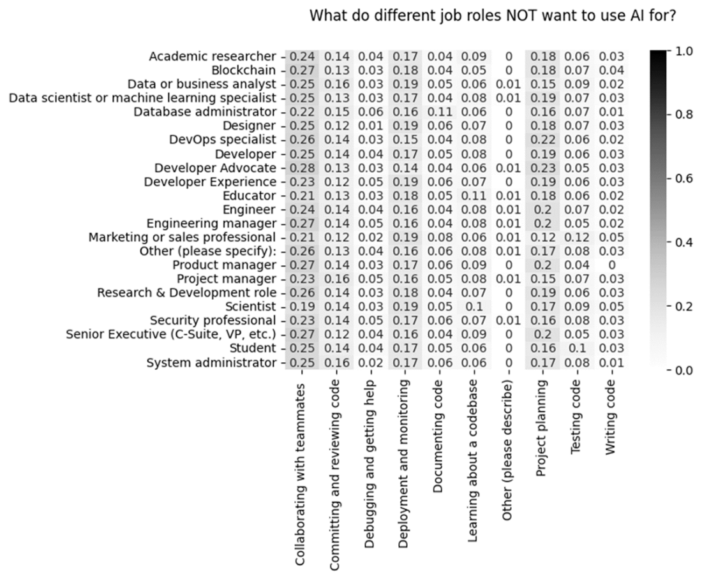
Neutral – some missing values
This final heatmap reveals that the reluctance to use AI for human collaboration, project planning, and deployment and monitoring is constant across job roles. There are some differences, such as marketing professionals scoring “testing code” the highest out of all job roles as something they don’t want to use AI for.
Before summarizing our results, let’s summarize our analytical process, visualizing the four parallel strands we pursued to get a Minimum Viable Answer to all of our stakeholders’ questions. Figure 7.16 shows this diagram.

Figure 7.16 summary of the entire analytical process
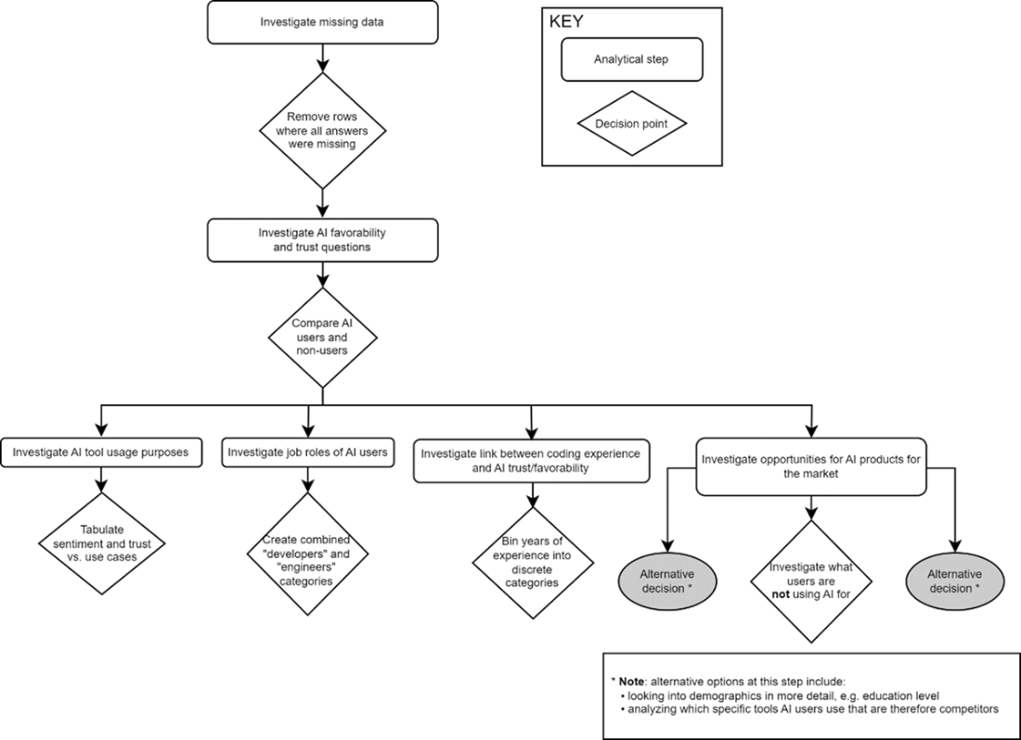 Up

Now, it’s time to summarize what we found and decide what to communicate back to our stakeholders.

Project results
Rather than summarize all of our findings, let’s focus on the ones directly related to our initial questions. Our stakeholders’ initial hypotheses were that:
- New and experienced coders are using these tools differently from each other.
- People’s opinions on the usefulness and trustworthiness of current AI tools depend on their experience, job role, and what specifically they use the tools for.
To answer these points, in our analysis, we found that:
- Writing and debugging code are the most popular AI use cases, but there is undeniable variation in what different job roles currently use AI tools for
- There are clearly use cases for AI that people are less interested in
- Existing users of AI tools seem to favor and trust these tools more than aspiring users
What can we recommend in terms of market gaps to exploit? We have seen that those who actively use AI tools are more likely to view them positively than potential users, so marketing the benefits of these tools is crucial. The market will already be saturated with AI-driven coding tools, so we should focus on the popular but less well-served use cases. Examples of this would include learning about a codebase, documenting existing code, and testing. We have also seen which gaps don’t exist; it does not seem sensible to pursue AI-driven collaboration or project management tools.
These findings are more than enough for an initial stakeholder review, but there are plenty of avenues in the data to explore the viability of an AI-driven discovery/documentation tool further, such as:
- There is a question about how often someone can find information within their business. We could cross-reference people who said “often” with the current and future use cases to gauge interest in such a tool.
- There is also a question about how long people spend searching for information. Again, this could be cross-referenced with answers about AI tools and use cases.
- Finally, there is a question about how often people need help from their team, which again could be explored as a way to get people interested in AI assistance.
During our analysis, we also encountered some limitations in our data that are worth communicating to our stakeholders. The data is heavily biased towards developers, specifically those active on Stack Overflow. Even the readme file for the dataset notes that “highly engaged users on Stack Overflow were more likely to notice the links for the survey and click to begin it.” This is not necessarily a bad case of selection bias since the target audience of our startup overlaps with engaged Stack Overflow users. We are missing the presence of developers who aren’t active online, and it would be worth quantifying this population and investigating other means of capturing their pain points and opinions.
We also do not have access to some of the free-type answers, which would have given us deeper insight into how people are using and want to use AI tools. Creating our own qualitative survey or interviews could help us get a better understanding of our target market.

Activity: Further project ideas with this data
The survey data used in this chapter has more dimensions that can be explored. As with all projects, I recommend taking the time to consider different research questions that could be answered. Some ideas to get you started:
- Is there a relationship between the tools that developers use and their opinions and usage of AI? There are survey questions about programming languages and other related tools that we did not explicitly explore in the project.
- There is a question about the industry the developer currently works in, which opens up opportunities to compare results across industries. Are some industries more forward-thinking with regard to AI than others?
- At the start of the survey, there are questions about how developers prefer to learn. Do answers to these questions relate to different stances toward AI?
It is worth highlighting that we have just scratched the surface of what information is available in the survey data, but our result-driven approach meant we only explored avenues that were immediately relevant to the question at hand. That is the value of starting with the end result in mind and having something concrete to work towards.
Any comments on section 7.2 Using advanced methods to answer further questions about categorical data?

Up

7.3 Closing thoughts on categorical data
The prevalence of categorical data in real business scenarios should not be underestimated. Any operational system where data entry consists of multiple choice options or dropdowns, customer surveys with discrete options, or data that contains hierarchies such as countries, regions, or departments will generate categorical data. Knowing the relevant options to treat this data correctly is crucial, especially because, in basic training, there is typically little time devoted to the subject. In trying to bridge the gap between training and the real world, understanding how to specifically handle categorical data, such as knowing methods like one-hot encoding, will go a long way.
Finally, let’s look at the skills covered by this chapter that are necessary for working with categorical data.

7.3.1 Recap: Skills for working with categorical data
In this chapter, we had to change our approach because we were dealing with survey data that contains many categorical variables. The specific skills that are required for this, which can be used for any problem involving survey data and categorical values, include:
- Understanding why data would be missing in a survey context, e.g., people deciding to omit certain answers
- Deciding on a natural order for ordinal variables, such as survey answers on a Likert scale
- Using pivot tables to cross-reference two categorical variables and optionally visualizing them with heatmaps
- Splitting multiple answers into separate columns, e.g., for multiple choice questions that allow more than one selection
- Turning categorical data into binary indicator variables for use in analyses
- Reshaping data from a wide to a long representation for easier cross-tabulation
- Using AI tools, such as ChatGPT, to continuously improve how we work
- Manipulating existing categories, e.g., combining similar ones, to add clarity to our analysis
- Choosing when to prefer categorical over continuous data, such as binning a continuous “age” column into fewer, broader categories
- Identifying the right statistical test to use based on our data types
Any comments on section 7.3 Closing thoughts on categorical data?

Up - Good summation of skills. Would make a good 'skills' cheat sheet.

7.4 Summary
- We used statistical tests appropriate for categorical data to answer our research questions
- We chose to create a categorical column from a continuous value to better answer a stakeholder question
- Throughout this project, we identified methods appropriate to the kind of data we were working with
What did you think of this chapter?
hide feedback

1
How many stars would you give this chapter?

5

2
What is your overall impression of this chapter?

Good job of differentiating the value and significance, between numerical data and categorical data. The example demonstrated how visualizations may be different for categorical values. First introduction to statistics, without being too technical.

